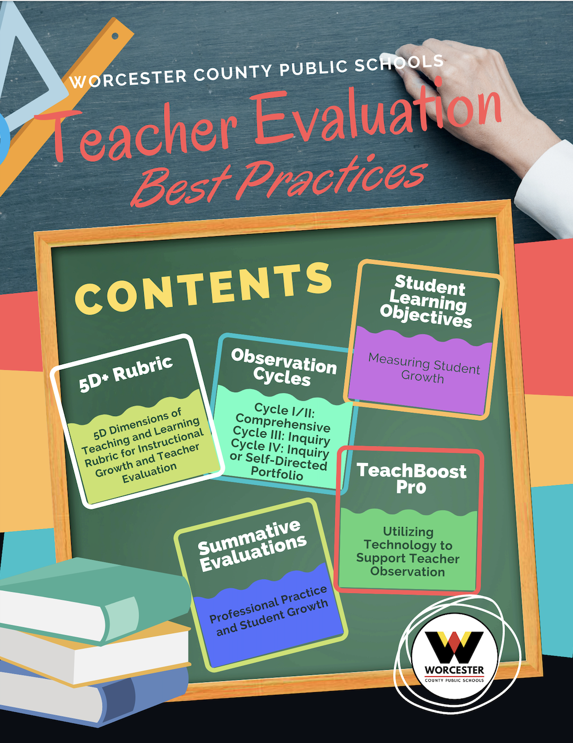

Teacher Observation/Professional Practice: Overview

In Worcester County Public Schools, teachers are evaluated annually. The evaluation is based on the following criteria:

Professional Practice- 60% of Total Score

- Classroom Observations using 5+ Dimensions of Teaching and Learning Rubric
- 6th Dimension Professional Rating

Student Growth- 40% of Total Score

- Student Learning Objective 1
- Student Learning Objective 2

Worcester County Public Schools Teacher Observation Best Practices

- Comprehensive Observations are completed using the “5D Dimensions of Teaching and Learning Rubric for Instructional Growth and Teacher Evaluation”.
- Observers document Noticings and Wonderings, identify areas of strength and focus, and use these as the basis for the post-observation conference when completing a comprehensive observation.
  - Noticings and Wonderings are included in each comprehensive observation and are located at the top of the observation report.
  - Areas of strength and focus are included within the comprehensive observation as Next Steps.
- The teacher and observer have a copy of Framework & Rubric in hand during the post-observation conference.
- Coordinators meet with school leadership to share the 5D through their lens and complete walk throughs and co-observations.
- Observers score all observed indicators and discuss missed opportunities.
- To support calibration, Principals, Assistant Principals and Coordinators co-evaluate twice a year.
- Per the Negotiated Agreement, teachers must be given a copy of the observation report within ten (10) working days of the observation unless a longer period has been mutually agreed upon. In WCPS, this can be measured by the electronic timestamp when the observer shares the observation with the teacher within the TeachBoost platform.
- Teachers and observers must utilize the electronic signature feature within TeachBoost for observations and evaluations.
Overview: 5D+ Rubric for Instructional Growth and Teacher Evaluation
(Center for Education Leadership at the University of Washington, College of Education, 2016)

The 5D+ Rubric for Instructional Growth and Teacher Evaluation (2016) is published by the Center for Education Leadership at the University of Washington College of Education. They state building the capacity of teachers will lead to better instruction and greater learning for all students. Helping educators understand what good teaching looks like is at the heart of the Center for Educational Leadership’s 5D+ Rubric for Instructional Growth and Teacher Evaluation- a growth-oriented tool for improving instruction.

Dimensions of the 5D+ Rubric for Instructional Growth and Teacher Evaluation
(Center for Education Leadership at the University of Washington, College of Education, 2016)

The 5D+ Rubric for Instructional Growth and Teacher Evaluation is based on the 5 Dimensions of Teaching and Learning instructional framework and is based on five core elements that contribute to high quality instruction. The five core elements are Purpose, Student Engagement, Curriculum and Pedagogy, Assessment for Student Learning, and Classroom Environment and Culture. The 5D+ Rubric also includes Professional Collaboration and Communication to capture activities and relationships that teachers engage in outside of the classroom that support professionalism and high levels of instruction.

Organization of the Rubric and Performance Levels
(Center for Education Leadership at the University of Washington, College of Education, 2016)

The 30 indicators (including the 6th Dimension) of teacher performance of the 5D+ Rubric are organized into dimensions, which represent the core elements of high-quality instruction. The performance levels within each indicator are used to delineate teaching practice, from unsatisfactory to basic, proficient to distinguished. The sophistication of teaching practice and the role of students increase across the levels of performance. A careful analysis of instructional practice leads to the determination of a teacher’s performance level on each indicator.

Note: In this guide, observation “look fors” at the distinguished performance level are identified for each of the domains. The intent is to highlight the teacher and student actions that must be evident at the highest level of the rubric. The observation “look fors” are not limited to the bullet points, but rather are the distinctions in the actions that will move the evaluation on the rubric from proficient to distinguished. Understanding the nuances as you move across the performance levels from unsatisfactory to basic to proficient to distinguished for a particular indicator should be the focus of learning around the 5D Rubric as the distinguished rating reflects the highest quality instruction.

Dimension 1: Purpose

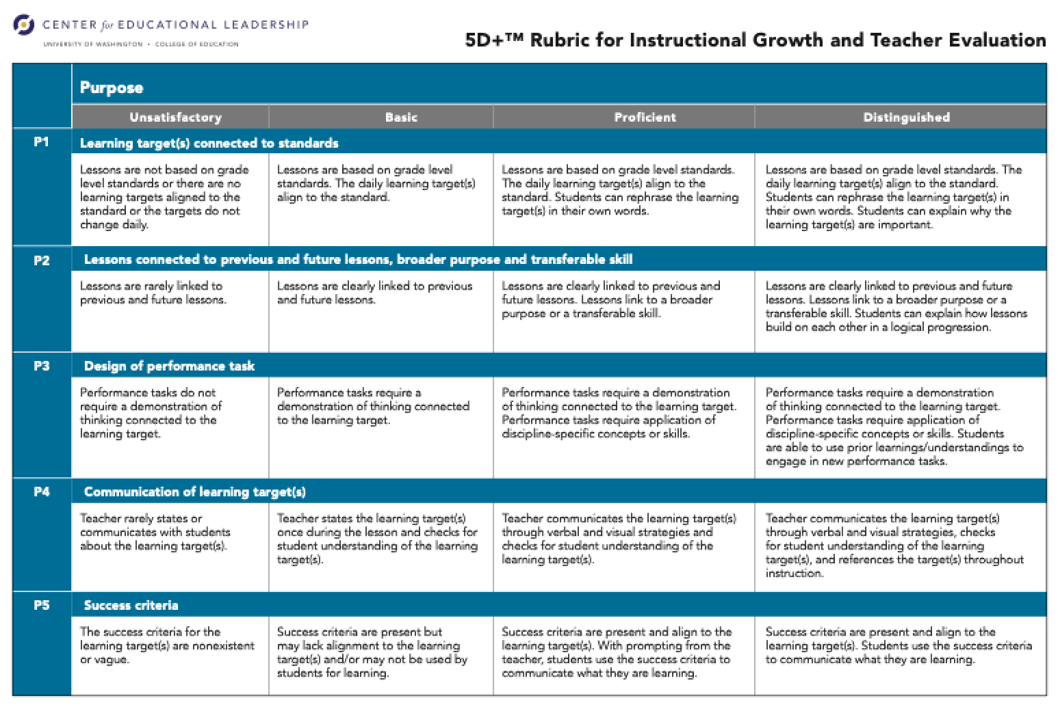
Guiding Questions when Observing Purpose, as identified in the 5 Dimensions and Teaching and Learning Instructional Framework 4.0:

- How do the standard and learning target relate to content knowledge, habits of thinking in the discipline, transferable skills, and students’ assessed needs as learners (re: language, culture, academic background)?
- How do the standard and learning target relate to the ongoing work of this classroom? To the intellectual lives of students beyond this classroom? To broader ideals such as problem-solving, citizenship, etc.?
- What is the learning target(s) of the lesson? How is it meaningful and relevant beyond the specific task/activity?
- Is the task/activity aligned with the learning target? How does what students are actually engaged in doing help them to achieve the desired outcome(s)?
- How are the standard(s) and learning target communicated and made accessible to all students?
- How do students communicate their understanding about what they are learning and why they are learning it?
- How does the learning target clearly communicate what students will know and be able to do as a result of the lesson? What will be acceptable evidence of student learning?
- How do teaching point(s) support the learning needs of individual students in meeting the learning target(s)?

Observation Look Fors when Observing Purpose at the Distinguished Performance Level

- Students can explain why learning targets are important.
- Students can explain how lessons build on each other in a logical progression.
- Students are able to use prior understandings to engage in new performance tasks.
- The teacher references the learning target multiple times during instruction.
- Students use the success criteria to communicate what they are learning.

Dimension 2: Student Engagement

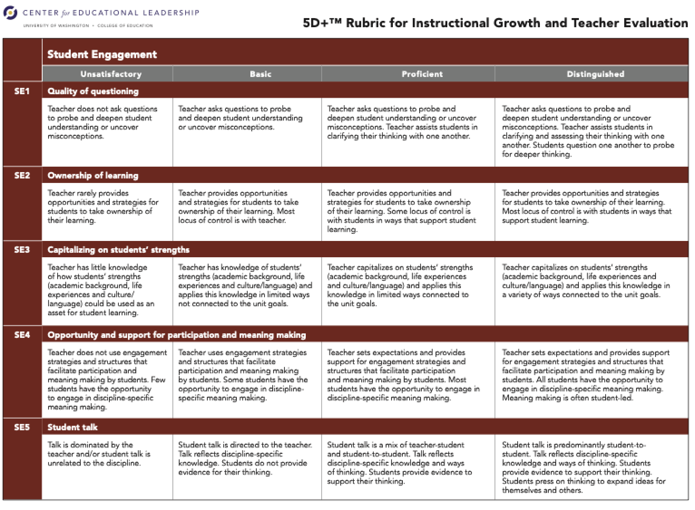Guiding Questions when Observing Student Engagement, as identified in the 5 Dimensions and Teaching and Learning Instructional Framework 4.0:

- What is the frequency of teacher talk, teacher-initiated questions, student-initiated questions, student-to-student interaction, student presentation of work, etc.?
- What does student talk reveal about the nature of students’ thinking?
- Where is the locus of control over learning in the classroom?
- What evidence do you observe of student engagement in intellectual, academic work? What is the nature of that work?
- What is the level and quality of the intellectual work in which students are engaged (e.g. factual recall, procedure, inference, analysis, meta-cognition)?
- What specific strategies and structures are in place to facilitate participation and meaning making by all students (e.g. small group work, partner talk, writing, etc.)?
- Do all students have access to participation in the work of the group? Why/why not? How is participation distributed?
- What questions, statements, and actions does the teacher use to encourage students to share their thinking with one another, to build on one another's ideas, and to assess their understanding of one another's ideas?

Observation Look Fors when Observing Student Engagement at the Distinguished Performance Level

- Students question one another to probe for deeper thinking.
- Most locus of control is with students in ways that support student learning.
- All students have the opportunity to engage in discipline-specific meaning making.
- Meaning making is student led.
- Students press on thinking to expand ideas for themselves and others.

Dimension 3: Curriculum & Pedagogy

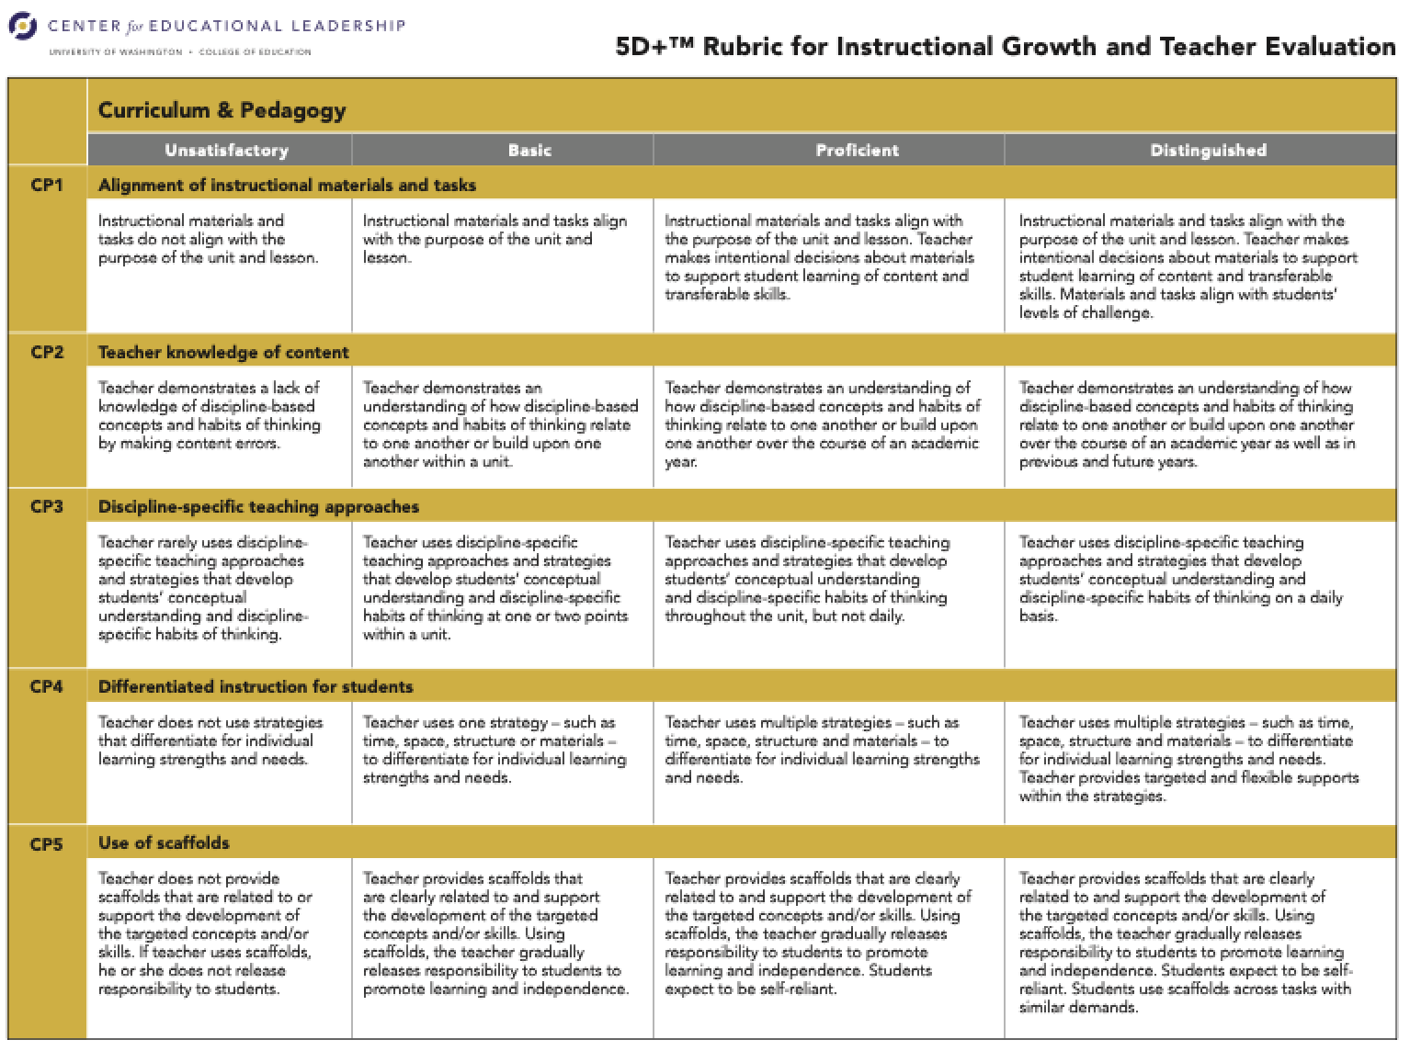

Guiding Questions when Observing Curriculum & Pedagogy, as identified in the 5 Dimensions and Teaching and Learning Instructional Framework 4.0:

- How does the learning in the classroom reflect authentic ways of reading, writing, thinking and reasoning in the discipline under study? (e.g., How does the work reflect what mathematicians do and how they think?)
- How does the content of the lesson (e.g., text or task) influence the intellectual demand (e.g. the thinking and reasoning required)? How does it align to grade-level standards?
- How does the teacher scaffold the learning to provide all students with access to intellectual work and to participation in meaning-making?
- What does the instruction reveal about the teacher’s understanding of how students learn, of disciplinary habits of thinking, and of content knowledge?
- How is students’ learning of content and transferable skills supported through the teacher’s intentional use of instructional strategies and materials?
- How does the teacher differentiate instruction for students with different learning needs—academic background, life experiences, culture and language?

Observation Look Fors when Observing Curriculum & Pedagogy at the Distinguished Performance Level

- Materials and tasks align with students’ levels of challenge.
- Teacher demonstrates and understanding of how discipline-based concepts and habits of thinking relate to one another or build upon one another over the course of an academic year as well as in previous or future years.
- Teacher uses discipline-specific teaching approaches and strategies that develop students’ conceptual understanding and discipline-specific habits of thinking on a daily basis.
- Differentiation- Teacher provides targeted and flexible supports within the strategies.
- Students use scaffolds across tasks with similar demands.

Dimension 4: Assessment for Student Learning

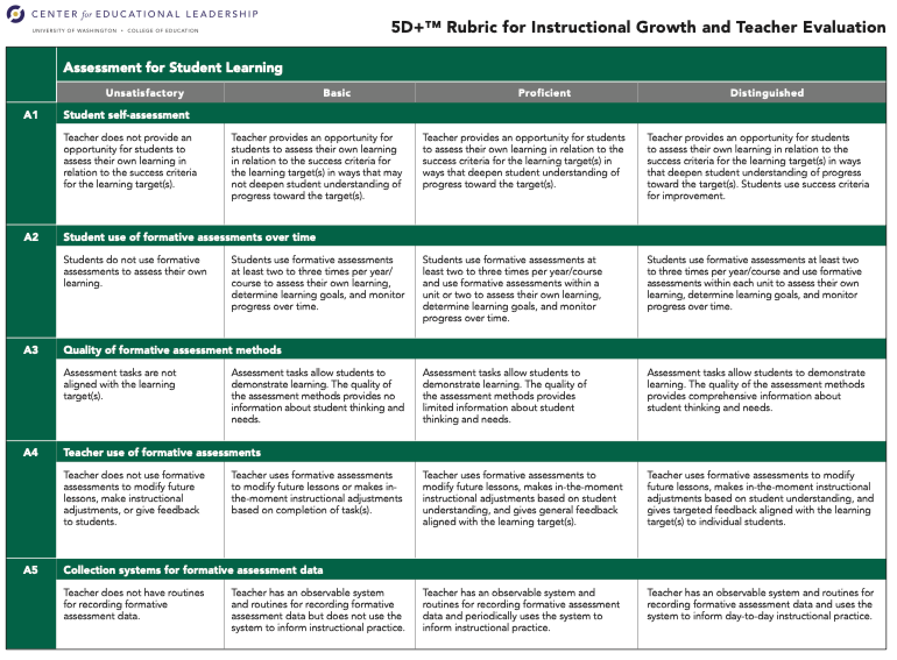
Guiding Questions when Observing Assessment for Student Learning, as identified in the 5 Dimensions and Teaching and Learning Instructional Framework 4.0:

- How does the instruction provide opportunities for all students to demonstrate learning? How does the teacher capitalize on those opportunities for the purposes of assessment?
- How does the teacher gather information about student learning? How comprehensive are the sources of data from which he/she draws?
- How does the teacher’s understanding of each student as a learner inform how the teacher pushes for depth and stretches boundaries of student thinking?
- How do students use assessment data to set learning goals and gauge progress to increase ownership in their learning?
- How does the teacher’s instruction reflect planning for assessment?
- How does the teacher use multiple forms of assessment to inform instruction and decision-making?
- How does the teacher adjust instruction based on in-the-moment assessment of student understanding?

Observation Look Fors when Observing Student Learning at the Distinguished Performance Level
- Students use success criteria for improvement.
- Students use formative assessment within each unit to assess their own learning, determine learning goals, and monitor progress over time.
- The quality of the assessment methods provides comprehensive information about student thinking and needs.
- Teacher uses assessment to provide targeted feedback aligned with the learning target(s) to individual students.
- Teacher has an observable system and routines for recording formative assessment data and uses the system to inform day-to-day instructional practices.

Dimension 5: Classroom Environment and Culture

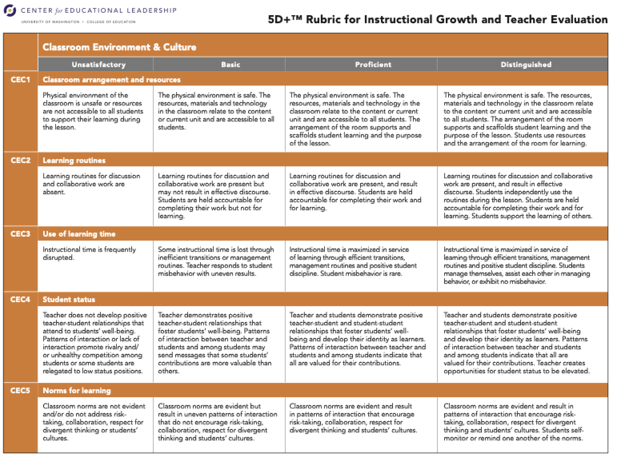

Guiding Questions when Observing Classroom Environment and Culture, as identified in the 5 Dimensions and Teaching and Learning Instructional Framework 4.0:

- How does the physical arrangement of the classroom, as well as the availability of resources and space to both the teacher and students, purposefully support and scaffold student learning?
- How and to what extent do the systems and routines of the classroom facilitate student ownership and independence?
- How and to what extent do the systems and routines of the classroom reflect values of community, inclusivity, equity and accountability for learning?
- What is the climate for learning in this classroom? How do relationships (teacher-student, student-student) support or hinder student learning?
- What do discourse and interactions reveal about what is valued in this classroom?
- What are sources of status and authority in this classroom (e.g., reasoning and justification, intellectual risk-taking, popularity, aggressiveness, etc.)?

Observation Look Fors when Observing Classroom Environment and Culture at the Distinguished Performance Level

- Students use resources and arrangement of the room for learning.
- Students support the learning of others.
- Students manage themselves, assist each other in managing behavior, or exhibit no misbehavior.
- Teacher creates opportunities for student status to be elevated.
- Students self-monitor or remind one another of the norms.

6th Dimensions Rating: Professional Collaboration and Communication

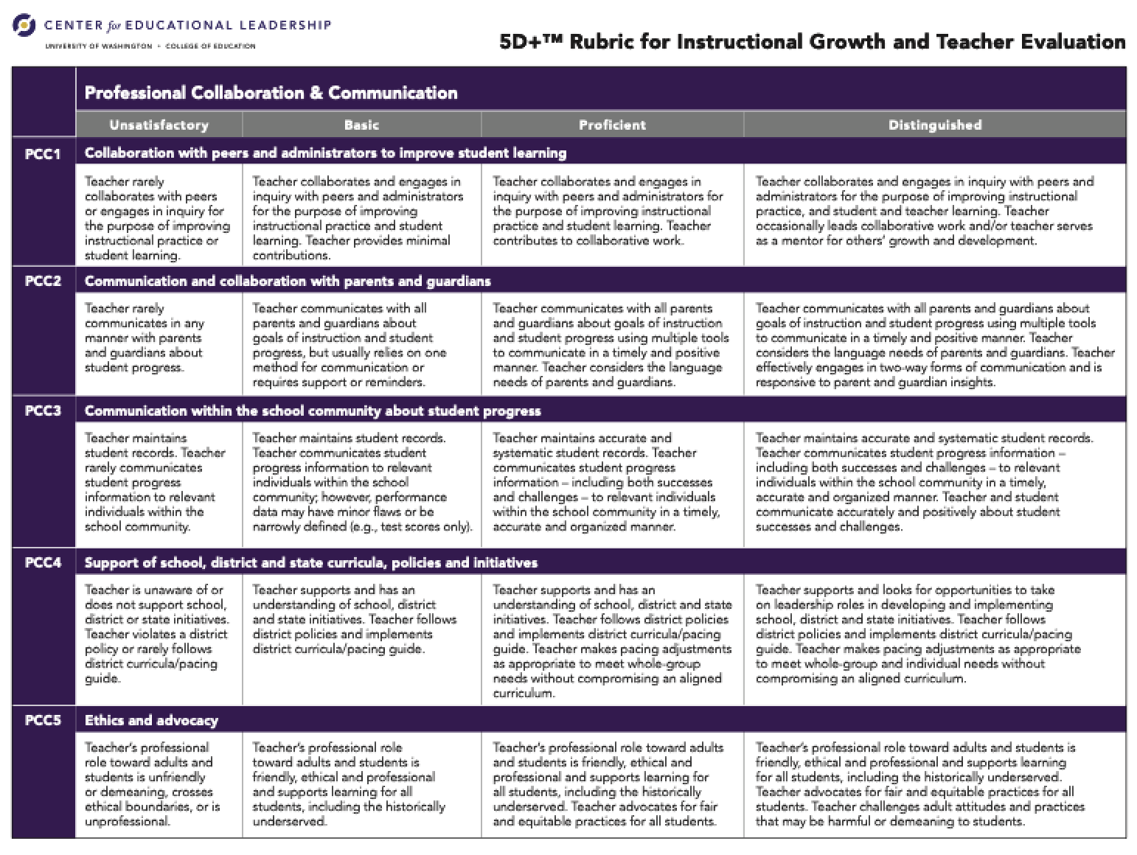
Best Practices for Administrators Evaluating the 6th Dimension Rating

Teacher Observation Cycles/Professional Practice Cycles

Every teacher, tenured and non-tenured, must participate in a professional practice cycle. Every year nontenured teachers will receive a comprehensive evaluation of the entire 5D+ Teacher Evaluation Rubric. Every third year a tenured teacher must have a comprehensive evaluation on professional practice. The cycles are as follows:

Cycle I- Comprehensive – Non-Tenured Teachers:

- Minimum of 4 Comprehensive observations, two per semester.
- Status of teacher progress will be reviewed at mid-year with SLOs.
- Support plan put in place if an observation is deemed ineffective by the principal.
- Teacher remains in Cycle 1 until tenured.

Cycle II- Comprehensive –Tenured Teachers:

- Minimum of 2 Comprehensive observations, one per semester.
- Status of teacher progress will be reviewed mid-year with SLOs.
- Support plan put in place if an observation is deemed ineffective by the principal.
- Teacher moves to Cycle III and retains his/her rating of highly effective or effective unless the teacher chooses to remain in Cycle II.

The principal also retains the right to keep the teacher in Cycle II, if deemed necessary.

Cycle III- Inquiry–Tenured Teachers:

- Minimum of 4 mini- observations (15-20 minutes) on Dimensions agreed upon by teacher and principal during preconference.
- Status of teacher progress will be reviewed mid-year with SLOs.
- Principals retain the option to move a teacher from an effective rating to a highly effective rating if the progress made during this cycle justifies it.
- Teacher moves to Cycle IV and continues to retain his/her rating of highly effective or effective from Cycle II unless the teacher chooses to remain in Cycle III.

The principal also retains the right to move the teacher back to Cycle II, if deemed necessary.

Cycle IV- Inquiry or Self-Directed (Video/Portfolio)-PLC–Tenured Teachers:

- Minimum of 4 mini- observations or 2 videos (15-20 minutes) on Dimensions agreed upon by teacher and principal during preconference or the teacher maintains a portfolio of artifacts that focus on areas agreed upon by teacher and principal during preconference.
- Status of teacher progress will be reviewed mid-year with SLOs.
- Principals retain the option to move a teacher from an effective rating to a highly effective rating if the progress made during this cycle justifies it.
- Teacher moves to Cycle II the following year.

Student Learning Objectives (SLOs)

A student learning objective (SLO) is an important measure of the success of a teacher and an instructional leader. In Maryland, it is a required part of the teacher evaluation model. An SLO is a measurable instructional goal established for a specific group of students over a set period.
SLOs have the most impact when they fully support the goal of increasing student achievement for all students.

SLO Process HS

SLO Process ES

SLO Planning/Preparation Guide
SLO Component | Description
- SLO Statement | The content is aligned to grade level Common Core Standards, Next Generations Standards or Industry standards. If you are in a state tested area (H.S.A., MCAP, MISA), use the data from testing.
- Data Review and Baseline Evidence | Explain baseline data and rationale for SLO, target population (an entire class doesn’t not have to be target) and outcomes. Baseline data should also be uploaded. If you are in a state tested area (H.S.A., MCAP, MISA), use the data from testing.
- Target Population | - This should be a breakdown of the students that you are targeting. It should include demographics as well as IEP, 504, Farms, and ELL information (target populations maybe a small focused group within a class or all of your classes. Ex. Students scoring a 3 on MCAP.)  - An attendance clause should be added here. (ex. Students with a minimum of 80% attendance rate etc.)
- Standards | - A list of specific standards being measured should be generated here.  - The standards selected should present an opportunity of growth and challenge. A brief explanation for their selection is also included here.
- Instructional Interval | Specific time interval of SLO
- Outcome | - The outcome is anchored in baseline data.  - The outcome statement should include 2 measures of student achievement. For example, 85% of the target population should score 80% or higher on the summative exam and at least a 2 or higher on the essay. It is encouraged that some type of application be incorporated to one of the 2 measures.  - If appropriate, the SLO differentiates (tiers) numerical components for individuals or groups of students based on baseline data so that all outcomes are rigorous yet attainable.  - The instructional interval should correlate to the numerical target.  - Outcomes utilizing a comprehensive diagnostic like iReady are considered to encompass multiple measures of student learning outcomes.
- Evidence of Growth | - List and explain the types of formative assessments you will use to support the outcome  - Provide data upon request
- Strategies | List of strategies used to achieve outcome (include both instructional strategies and professional learning that supports the implementation of the SLO)
- Target Criteria | Explain the breakdown of:  85-100% Highly Effective  60-84% Effective  59% or less Does not meet

Utilizing the TeachBoost Pro Platform to Support Teacher Observation, Evaluation and Growth

Teacher Self-Reflection

The self-reflection tool is available in TeachBoost. Principals and teachers may utilize this tool at the start of each school year. The purpose is to rate proficiency with individual indicators and set goals for growth during the school year. This self-reflection can serve as the basis of ongoing conversations between the observer and teacher.

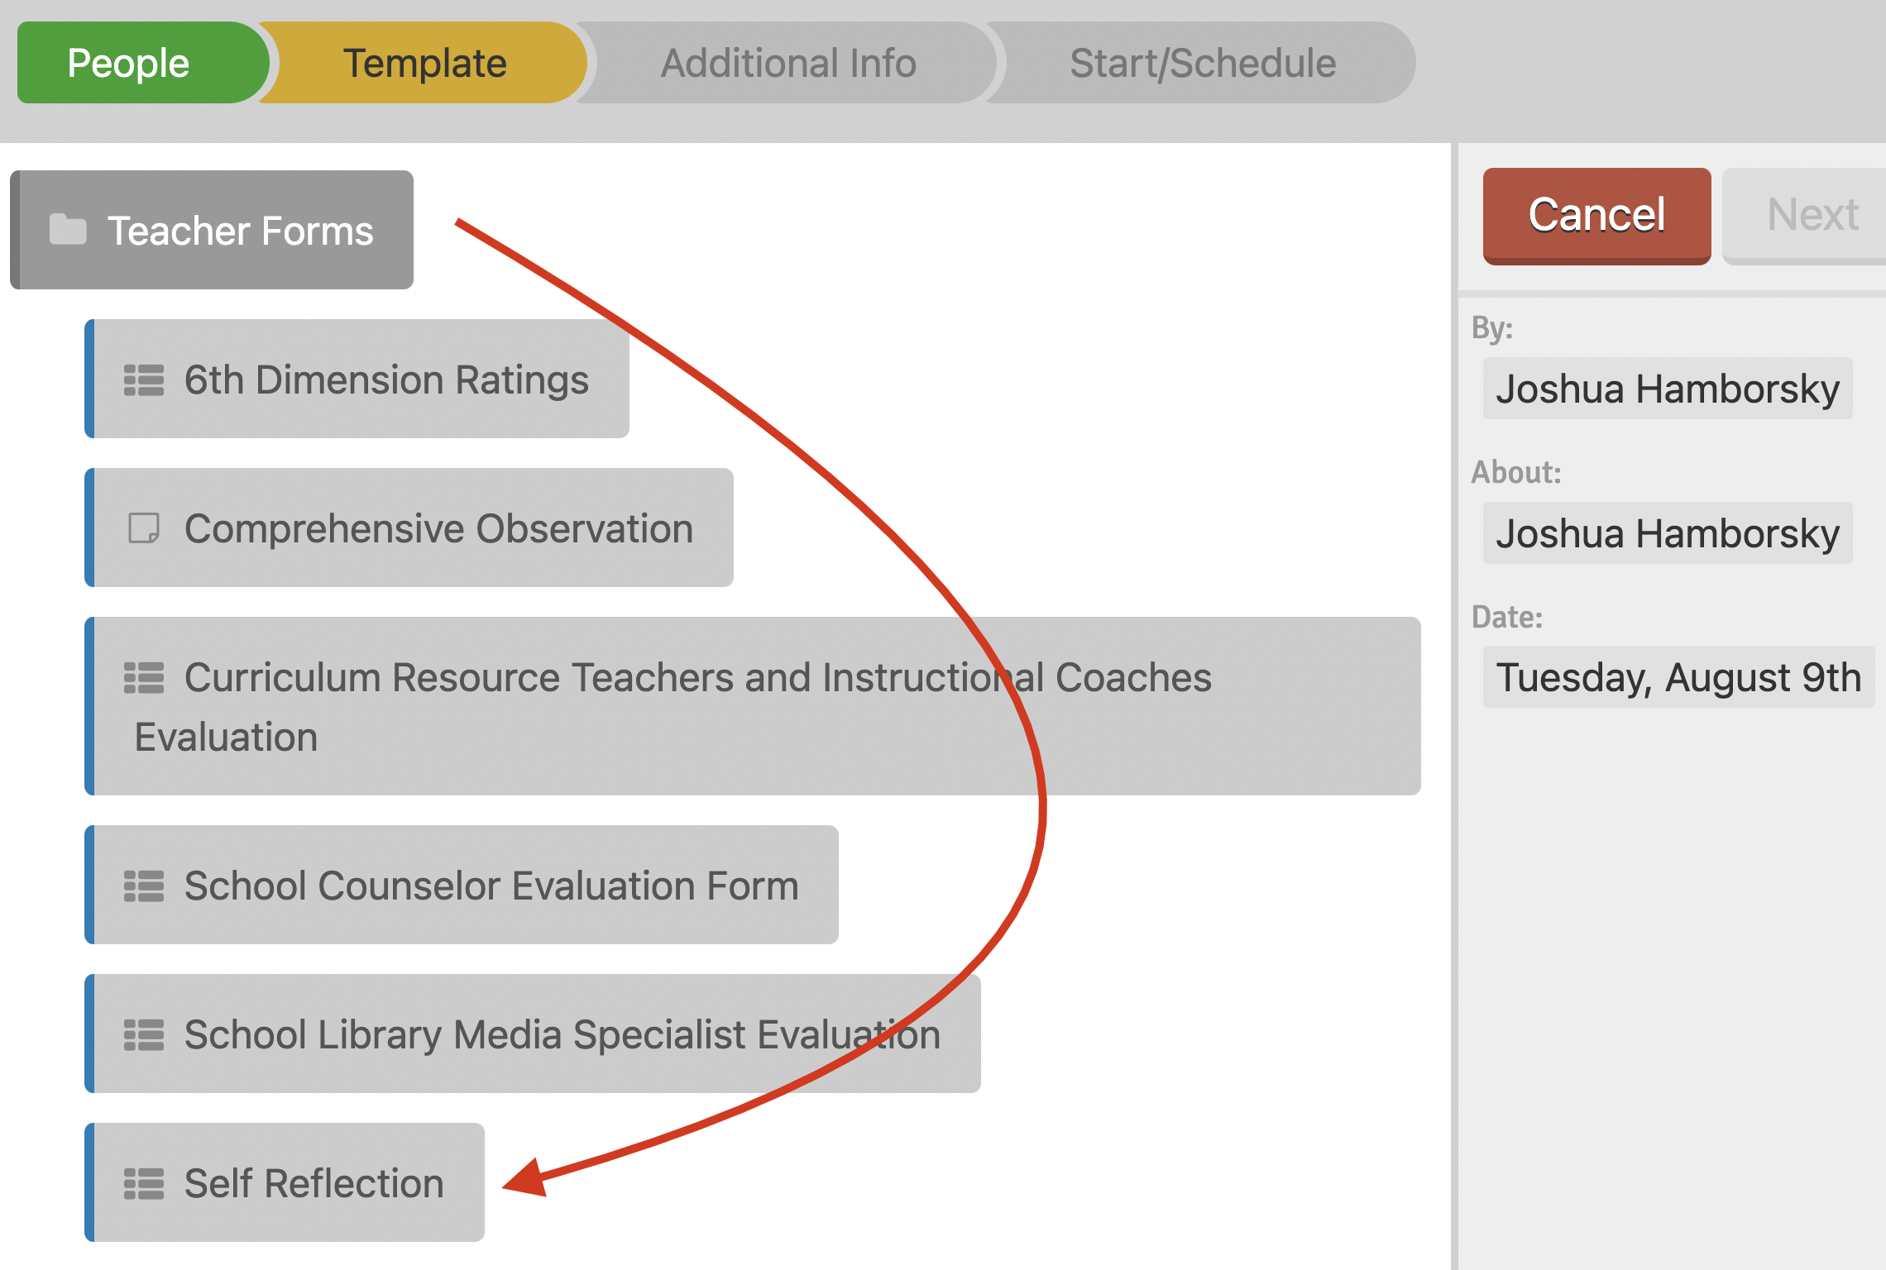

Student Learning Objectives (SLOs)

A student learning objective (SLO) is an important measure of the success of a teacher and an instructional leader. In Maryland, it is a required part of the teacher evaluation model. An SLO is a measurable instructional goal established for a specific group of students over a set period.
SLOs have the most impact when they fully support the goal of increasing student achievement for all students.

For each SLO, it is imperative the teacher captures the data source using the dropdowns available and includes the SLO performance rating to be converted in the Summative Evaluation as both of these data points are reported annually to the Maryland State Department of Education in the Teacher Principal Evaluation File.

Summative Evaluations

The Summative evaluation is completed by the supervisor at the end of the year and captures the overall rating that is reported to The Maryland State Department of Education. It is accessed in Teach Boost.

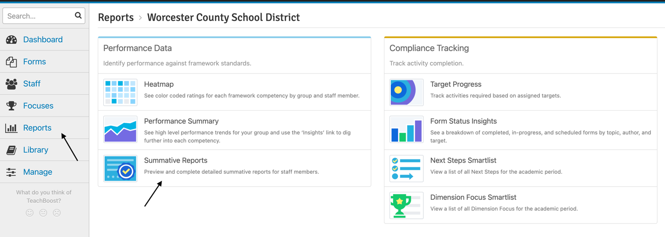
In the Summative Evaluation, the Professional Practice Rating (60%) and the 6th Dimension Rating are transferred within the Teach Boost Platform. The numeric rating for the SLOs (40%) should be entered by the evaluator using the following conversions:

Ratings for Professional Practice

Distinguished | Proficient | Basic | Unsatisfactory
4.0 - 3.5 | 3.49 - 2.5 | 2.49 - 1.5 | 1.49 – 1.0

Student Learning Objective Ratings (SLO)

Highly Effective | Effective | Ineffective
100% = 4 | 82.5% = 3.3 | 47.5% = 1.9
97.5% = 3.9 | 80% = 3.2 | 45% = 1.8
95% = 3.8 | 78.5% = 3.1 | 42.5% = 1.7
92.5% = 3.7 | 75% = 3.0 | 40% = 1.6
90% = 3.6 | 72.5% = 2.9 | 37.5% = 1.5
87.5% = 3.5 | 70% = 2.8 | 35% = 1.4
85% = 3.4 | 68.5% = 2.7 | 32.5% = 1.3
 | 65% = 2.6 | 30% = 1.2
 | 62.5% = 2.5 | 27.5% = 1.1
 | 60% = 2.4 | 25% = 1.0
 | 58.5% = 2.3
 | 55% = 2.2
 | 52.5% = 2.1
 | 50% = 2.0

